²
DEAR AUTHORS, PLEASE ENTER YOUR TEXT, TABLES, CHARTS AND FIGURES DIRECTLY INTO THIS TEMPLATE DOCUMENT, ACCORDING TO THE PRESENTED INSTRUCTIONS
² (Red mark, sign of one empty row. Please delete red marks when finish your paper)
²
Paper category (reviewer fills)

²
²
title (Upper case, Times New Roman 12 PT BOLD, centered)
²
First author*¹ - Full first name and family name (no affiliations, tnr 10 pt bold), Second author² - Full first name and family name², . . .
²
¹Authors affiliations (full official title of the institution, town, country), tnr 10 pt italic, centered)
² University of Belgrade, Faculty of Agriculture, Institute of Agricultural Engineering, Belgrade
²
²
Abstract: The paper must have an abstract of 100 to 250 words, supplying general information about the objectives of the paper, experimental techniques, methods applied, significant results, and conclusions. Do not use tables, charts, figures and literature citations. Abstract is followed by maximum 10 key words, separated by commas.
Key words: word, word, word . . . (maximum 10 words; tnr 10 pt italic)
²
²
Introduction (first level subtitle, uppercase, tnr 10 pt bold, centered)
²
Paper title, names of authors and subtitles should be centered.
Write the paper title in UPPERCASE LETTERS, font size 12, bold.
Authors (full first names and family names) – lowercase letters, font size 10, bold.
Authors address - lowercase letters, font size 10, italic.
Enter full first names and family names without titles and affiliations. Mark each name with the number in superscript behind, to connect it to the corresponding institution. Only for contact author note the e-mail address together with the postal address (in footnote).
Write I LEVEL SUBTITLES in UPPERCASE LETTERS, font size 10, bold.
Write II level subtitles in lowercase letters, font size 10, bold.
For spacing use only empty rows (marked with ² font size 10) in following cases: before and after subtitle, between the title and authors names, between authors names and authors addresses, before and after the table or figure title, after table or figure.
Original scientific paper should contain: Abstract, Key words, Introduction, Material and Methods, Results and Discussion, Conclusions and Bibliography.
The text, maximum 10 pages, including full text, tables, charts, figures, etc., should be prepared on A4 format paper (210 × 297 mm). Margins: Top > 53 mm, Bottom > 53 mm, Left > 42 mm, Right > 42 mm (margins of this template).
Paper should be typed in font > Times New Roman (tnr), font size > 10 pt, line spacing > Single, alignment > Justified, indentation > First line (63 mm).
Before and after paragraphs insert blank (empty) rows only (regular font tnr, size 10).
²
²
MATerial and methods
²
Symbols for variables, marks, labels, etc. must be identical in the text, equations, figures, tables and nomenclature. Variables must be in italic style.
Use only the units from SI system. Words and abbreviations from Latin language should be written in italic letters (Zea mays L.).
²
Table 1. Table title (tnr 9 pt, italic)
Biomass | Utilization | Actual capacity
Biomass | Utilization | Unit | Capacity | Biomass demand
Wood chips | Electricity | 5 | 140 | 1000
Wood chips | Central heating | 5 | 24 | 25
Straw | Power plant | - | - | -
Total |  | 10 | 164 | 1025
²
Numeration of tables, charts, figures, photos etc. (high resolution and contrast) should be included in text (Tab. 1, Fig. 2, etc.). Table numeration and title should be inserted above the table. Table borders should be normal style continuous lines > Line Weight ½. Text in tables > tnr, Font size 9 pt.
²
²
Results and Discussion
²
References should be numbered in brackets in the order of appearance in the text, e. g. [1], [3, 4], [7-11], etc. The full references should be listed at the end of the paper in numerical order of citation in the text.
All equations, formulas, and expressions should be numbered in parentheses e. g. (1), with right alignment, in the order of appearance in the text, and must be centered with one line left above and below.
Also, equations, formulas, and expressions should be referenced within the text with eq. or formula or expression, with corresponding number in parentheses, as eq. (5). Equations should be written in equation editor (MS Equation 3.0 or Mathtype) with the basic font size > tnr 10 pt.
²
 | $$m⋅\overset{¨}{x}+k⋅\overset{˙}{x}+c⋅x=F(t)+F_{\text{AKT}}$$ | (1)
²
Figures and charts should also be numerated (Graph. 1). Numbers and titles should be entered below the chart or figure (Fig. 1). Give the title and numeration in Normal style.
²
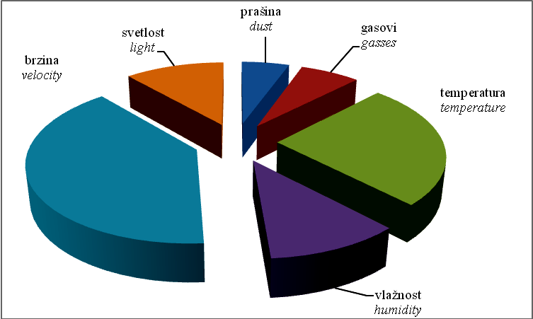
Chart 1. Chart title (tnr 9 pt italic)
²
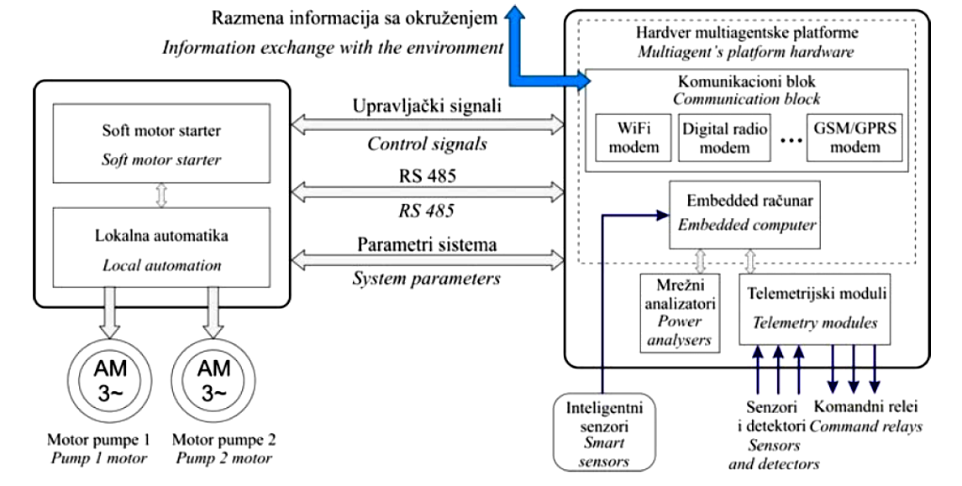
Figure 1. Figure title (tnr 9 pt italic)
²
²
Conclusions
²
Please check once again if you have formatted your full paper according to the given instructions.
²
²
REFERENCES
²
Do not list the titles of the literature that is not cited in tekst.
Bibliography > font tnr 9 pt, numeration with numbers in brackets. Format the listed titles as follows:

Journal:
- Last name of Author 1, Initial of authors 1 First name., Author2 I., Author3 I. Year. Title of the paper, in original language only (do not translate in English). Full title of journal, Volume number (Issue /Part number), Page numbers.
Book:
- Last name of Author/Editor 1, Initial of authors 1 First name., Author2 I., Author3 I. Year. Title of book. Title of the book. Edition. Place: Publisher.
Chapter:
- Chapter author(s) surname(s) and initials. Year of chapter. Title of chapter followed by In: Book editor(s) initials and surnames with ed. or eds. after the last name. Year of book. Title of book. Place of publication: Publisher. Chapter number or first and last page numbers followed by full-stop.
Web site:
- Author, Year, Title. [type of medium] Place of publication: Publisher. Followed by “Available through:” include e-book source/database, web address or URL [Accessed date].
²
²
²
Prijavljen:
Submitted:
Ispravljen:  Revised: | AUTHOR DOES NOT FILL THIS PART
Prihvaćen:
Accepted:

* Corresponding author. E-mail: xx@xx.xx (AUTHOR FILLS this footnote) Acknowledgements

